EEEE3001

Final Year Individual Project Dissertation

Diode Clamped Inverter for Vehicle AC Machine Drive

AUTHOR: Mr. Pengyuan Shu

ID NUMBER: 20321149

SUPERVISOR: Dr. Alan Watson

MODERATOR: Dr. Gaurang Vakil

DATE: 9 May 2024

This third year project Dissertation is submitted in part fulfilment of the requirements of the degree of Bachelor of Engineering.

**Table of Contents**

**Abstract (1 pages)**

**Chapter 1: Introduction (3 pages)**

* 1. Background and Summary of Literature Review

*1.2* Aims and Objectives

**Chapter 2: Simulation and Controller Design (15 pages)**

*2.1* Specifications of Tool Choice

*2.2* PMSM Motor Modelling

*2.3* Field-Oriented Control (FOC)

*2.4* Topology Overview and Control Diagram

*2.5* SPWM and SVPWM

*2.6* Design of Current and Speed Controllers

*2.7* Design of DC-Link Voltage Balance Controller

*2.8* Loss Calculations

**Chapter 3: Hardware Design: Diode Clamped Inverter (8 pages)**

*3.1* PCB Layout

*3.2* Selection of Components

*3.3* Gate Drive Circuit

*3.4* DC-Link Capacitors

**Chapter 4: Hardware Design: Control Board and its Peripherals (3 pages)**

*4.1* PCB Layout

*4.2* ADC Sampling

**Chapter 5: Software Design: Implementation on MCU (6 pages)**

*5.1* Files Structure and IDE Configurations

*5.2* Algorithm Implementation

**Chapter 6: System Testing, Validation, and Analysis (8 pages)**

*6.1* Testing and Validation

*6.2* Results Analysis

**Chapter 7: Conclusion and Reflection (4 pages)**

*7.1* Consideration of System within Wider Context

*7.2* Reflection on Management

**References**

**Appendix**

**Abstract**

**Chapter 1: Introduction**

* 1. **Background and Summary of Literature Review**
     1. **Introduction to PMSM**

Permanent Magnet Synchronous Machines (PMSMs) are a class of electric motors that utilize permanent magnets embedded in the surface of the motor's rotor. This design is fundamental in creating a magnetic field that synchronizes with the rotating magnetic field of the stator. Efficiency is one of the distinguishing characteristics of PMSMs; the permanent magnets provide a steady magnetic field without the stator current, which is normally needed in other kinds of motors to maintain the field via the rotor windings.

The PMSM stands out for its high-power density, which is the amount of power generated per unit volume of the motor. This feature is particularly beneficial in the applications where space and weight are constrained, such as in automotive or aerospace industries. Another advantage of PMSMs is their high operational efficiency throughout a wide range of speeds and loads. This adaptability is complemented by their remarkable torque-to-weight ratio, which allows them to produce more torque per unit of motor weight than many other motor types. Moreover, PMSMs are also noted for their quiet operation and low maintenance requirements due to the lack of brushes and slide rings, which are prone to wear and strain.

The PMSM's torque generation capability is a direct consequence of the electromagnetic interaction between the stator's rotating magnetic field and the rotor's permanent magnets. This interaction produces torque that is precisely controllable, which is why PMSMs are ideal candidates for variable speed and position control applications.

* + 1. **Introduction to Diode Clamped Inverter**

The diode clamped inverters, also known as Neutral Point Clamped (NPC) inverters, can convert direct current (DC) to alternating current (AC) in a variety of applications. They are characterized by their multilevel output, which can generate voltage waveforms with steps at several voltage levels, not just the two levels produced by traditional two-level inverters. This ability to approximate sinusoidal waveforms more closely results in lower total harmonic distortion (THD). Due to their superior waveform quality, these types of inverters are commonly used as the drives for high frequency motors [1]. This intrinsic feature enables it to generate high-frequency AC voltages for the PMSM with significantly less harmonic distortion, and thus, the pulsations caused by these harmonics is significantly reduced.

In the three-phase diode clamped inverter topology, each phase leg includes several power semiconductor switches (could be MOSFET or IGBT) and clamping diodes. The clamping diodes are critical components that allow the inverter to maintain the voltage balance of the DC-link capacitors during operation, thereby ensuring the generation of the desired multi-level AC waveform. In this project, a three-phase three-level diode clamped inverter is used as the drive of PMSM motor, the topology is shown in the **Figure 1.1** below. Three-level means each phase of the inverter can generate three different levels of voltage, which are , 0V, and .

**Figure 1.1** Topology of Three-Phase Three-Level Diode Clamped Inverter

* + 1. **Field-Oriented Control (FOC)**

Field-Oriented Control (FOC), also known as vector control, is an advanced method of motor control that treats the electric motor as a controllable entity in two orthogonal components [2, 3]. This control technique allows for separate control of the magnetic flux and torque in AC machines (such as PMSM), by aligning the reference frame of the control system with the vector space of the motor’s magnetic field. Essentially, FOC decouples the PMSM's torque and magnetic flux into two independent variables that can be controlled as if the motor were a direct current (DC) motor.

* + 1. **Review of Existing Technologies and Developments**

Inverter technology has advanced significantly, especially in the area of electric vehicle (EV) propulsion. Innovations in semiconductor materials, such as Silicon Carbide (SiC) and Gallium Nitride (GaN), have been critical in spawning a new generation of inverters. These new inverters offer increased power densities and efficiency, as well as the extraordinary ability to perform optimally at high frequencies and temperatures. The consequence is a significant reduction in the physical bulk and weight of inverter systems, as well as an increase in their dependability and operational lifespan.

Meanwhile, for control algorithm, there is also a technique called sensorless control, which eliminate the need for physical sensors in the motor by using estimators and observers to infer the rotor position. However, due to the complexity of algorithm, and issue of robustness, it would not be covered in this report.

* 1. **Aims and Objectives**

The aim of this project is to achieve current and speed control of the PMSM motor (300V, BSM90N-175) through a three-phase three-level diode clamped inverter in PLECS and in reality. The inverter is controlled by TI’s F28379D Launchpad. For safety concerns, only low power situation (2kW) would be considered.

The project can be divided into following stages:

**Stage 1: Initial Simulation of FOC in PLECS**

**Aim:**

Create a mathematical model of PMSM motor in PLECS, and implement FOC in PLECS to verify the minimum acceptable capacitance of the DC-link capacitors.

**Objectives:**

* Work out the mathematical model of BSM90N-175 motor.
* Learn the working principles of Field-Oriented Control, build the continuous control model in PLECS.
* Change the target torque current to verify the performance of the two DC-link capacitors with calculated capacitance value, then work out the minimum acceptable value of capacitance and find the most suitable capacitor on the market.

**Stage 2: Hardware Design in KiCad and Manufacturing**

**Aim:**

Design a four-layer printed circuit board (PCB) for the three-phase three-level diode clamped inverter, as well as design a two-layer PCB for the control board (F28379D Launchpad) and its peripherals.

**Objectives:**

* Selection of components, build bill-of-materials (BOM) lists for purchasing.
* Schematic of the control board and the board of diode clamped inverter in KiCad, which includes gate drive circuit, ADC sampling circuit, connectors, etc.
* PCB layout in KiCad.

**Stage 3: Controller Design in PLECS and MATLAB**

**Aim:**

Design the continuous PI controller of speed, DC voltage balancing, and d-axis and q-axis current in MATLAB, convert them to discrete controllers and test in PLECS.

**Objectives:**

* Transfer functions of these continuous PI controllers from the “sisotool” in MATLAB.
* Convert the continuous PI controllers to discrete PI controllers.
* Test the discrete PI controller in PLECS.
* Convert the function blocks to “c-script” blocks in PLECS.

**Stage 4: Software Design in Code Composer Studio (CCS)**

**Aim:**

Convert the control algorithm and overall logic in PLECS file to C code that can be built and loaded on TMS320F28379D micro-controller, then test the program in real PMSM motor to verify the current and speed control.

**Objectives:**

* Configurate the environment of CCS, including file search path, library search path, predefined symbols, optimization configurations, etc.
* Construction of CCS program, which includes ADC sampling, motor encoder decoding, PI controller implementation, timer interruption, SPWM generation, etc.
* Test the program in real BSM90N-175 motor with the two PCBs to verify the speed and current control.

**Chapter 2: Simulation and Controller Design**

***2.1* Specifications of Tool Choice**

PLECS (Piecewise Linear Electrical Circuit Simulation) is chosen to be the tool of circuit simulation. It is a better choice than MATLAB in simulating electrical circuits for following reasons:

* PLECS can offer faster simulation times due to its optimized solvers.
* PLECS can offer real-time simulation capabilities for hardware-in-the-loop (HIL) testing. This feature is useful for testing the control logic on actual hardware before deployment.
* PLECS provides integrated thermal modelling, which enables the simulation of temperature-dependent behaviours of components and systems.

However, PLECS is not a suitable tool for controller design. For PI controller design, a tool named “sisotool” in MATLAB is used, which is an interactive graphical user interface (GUI) tool for designing and analysing single-input, single-output (SISO) control systems. It offers a variety of plotting functions, including bode plots, root locus, and step response plots, which are essential for understanding the frequency and time domain characteristics of the system.

***2.2* PMSM Motor Modelling**

The model is chosen to be ABB’s BSM90N-175. The electrical and mechanical parameters of this motor are shown in **Table 2.1** below.

**Table 2.1** Parameters of BSM90N-175 Model

|  |  |
| --- | --- |
| Rated Speed (at 300 V) | 4000 rpm |
| Torque Constant | 0.853 Nm/amp |
| Stator Resistance | 1.24 ohms |
| Stator Inductance | 4.15 mH |
| Pole Pairs | 4 |
| Inertia | 3.389 Kg- |

The electrical model of PMSM in PLECS is modelled by:

**Figure 2.1** Electrical Model of PMSM in PLECS (left: d-axis; right: q-axis)

The stator flux linkages are given by:

*Eqn.2.1*

*Eqn.2.2*

where the symbol represents the constant flux linkage, the symbol and represent stator inductance in d-axis and q-axis.

The three-phase stator currents are transformed to the two-dimensional rotating reference dq-frame, which converts an AC system into an equivalent DC system. This enables the use of traditional PI controllers with zero steady-state error. According to **Figure 2.1**, the stator voltage in d-axis and q-axis are given by:

*Eqn.2.3*

*Eqn.2.4*

Due to the AC motor is a synchronous machine with surface-mounted magnets and no saliency, flux lines are distributed evenly around the stator, which means that the motor's inductance measured in the direction of the d-axis and the q-axis will be the same. Thus:

*Eqn.2.5*

This equality leads to a simplified Field-Oriented Control algorithm, because the current-regulating controller does not have to compensate for differences in inductance in different orientations of the rotor. As they are equal, and can be represented by . Thus, *Eqn.2.3* and *Eqn.2.4* can be rearranged as:

*Eqn.2.6*

*Eqn.2.7*

where the electrical rotor speed .

Moreover, according to the manual of PLECS, electromagnetic torque and mechanical rotor speed of PMSM model in PLECS are given by:

*Eqn.2.8*

*Eqn.2.9*

*Eqn.2.10*

where the symbol represents the friction coefficient.

The configurations of initialising PMSM in PLECS are presented in **Figure 2.2** and **Figure 2.3** below, whose data are referred from the datasheet of BSM90N-175 motor. The model of PMSM is chosen to be “Rotor reference frame”, as it can decouple the motor’s flux and torque. In addition, the friction coefficient is assumed to be zero for simplification.

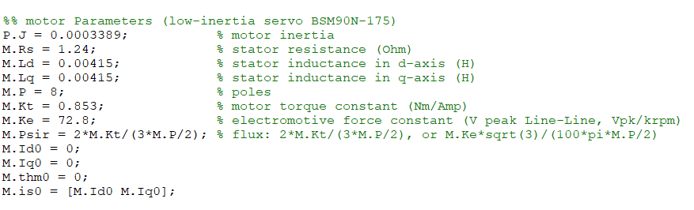

**Figure 2.2** C-Code for Simulation Parameter Initialization in PLECS

**Figure 2.3** Configurations of PMSM Model in PLECS

***2.3* Field-Oriented Control (FOC)**

Field-Oriented Control is a control technique used in variable frequency drives to control the torque (and thus speed and position) of three-phase AC electric motors by controlling the current components independently. The essence of this algorithm is to decompose the stator currents into two orthogonal components that can be controlled separately: one aligns with the rotor's magnetic field (direct axis, or d-axis), and the other is perpendicular to it (quadrature axis, or q-axis). This decomposition allows the control system to adjust the torque and magnetic flux of the motor independently, like DC motor, which is easier to control because torque is directly controlled by armature current.

The procedures of FOC are demonstrated as follows:

1. Sample the phase currents of PMSM and get , , and .
2. Convert , , to , via Clark Transformation.
3. Convert , to , via Park Transformation.
4. Calculate the errors between measured , and target , , enter the errors to two PI controllers and get control voltage , .
5. Convert , to , via Inverse Park Transformation.

***2.4* Topology Overview and Control Diagram**

Each phase of the inverter contains four IGBTs (with diode) to control the voltage level between S2 and S3 by switching. The other two diodes in each phase help in maintaining the voltage balance across the two DC-link capacitors. The truth table of switching is presented in **Table 2.2** below.

**Table 2.2** Truth Table of Phase Voltage

|  |  |  |  |  |
| --- | --- | --- | --- | --- |
| **Phase Voltage** | **S1** | **S2** | **S3** | **S4** |
|  | 1 | 1 | 0 | 0 |
| **0** | 0 | 1 | 1 | 0 |
|  | 0 | 0 | 1 | 1 |

It can be observed from the **Figure 1.1** that there are two DC-link capacitors between DC voltage source and IGBT bridges. The two capacitors are not only used for dividing the DC voltage, but also act as a decoupling element between the power supply (which may include batteries, photovoltaic arrays, or rectifiers) and the inverter. It helps to minimize the injection of harmonics back into the power source and also reduces the harmonic content in the output AC waveform.

The controller takes the 2-phase current and PMSM motor’s angle and speed as input, and output the PWMs for each IGBT in the inverter. The controller contains three closed control loops: the current control loop contains two parallel loops (d-axis and q-axis), and speed control loop is in series with the q-axis current control loop. The current loop can also be referred as the torque loop because the torque of PMSM motor is proportional to its stator current. This is where the FOC algorithm can be applied, combined with the PI controllers to control the three-phase current and voltage to generate target torque according to the position of the rotor.

The main topology of the circuit for simulation in the PLECS is shown in **Figure 2.5** below.

**Figure 2.5** Main Topology of Simulation

The 20k ohms resistors that connected in parallel with the DC-link capacitors can help balance the voltage across each capacitor. Moreover, when the system is turned off, the capacitors can hold a charge for a significant amount of time. The resistors provide a discharge path for the stored energy, ensuring that the capacitors discharge safely and relatively quickly, which is important for maintenance and safety reasons.

According to *Eqn.2.6* and *Eqn.2.7*, the transformation from the three-phase to the dq-frame brings cross-coupling between the d-axis and the q-axis, which have to be considered in the controller structure. Therefore, the overall control diagram is shown in the **Figure 2.6** below.

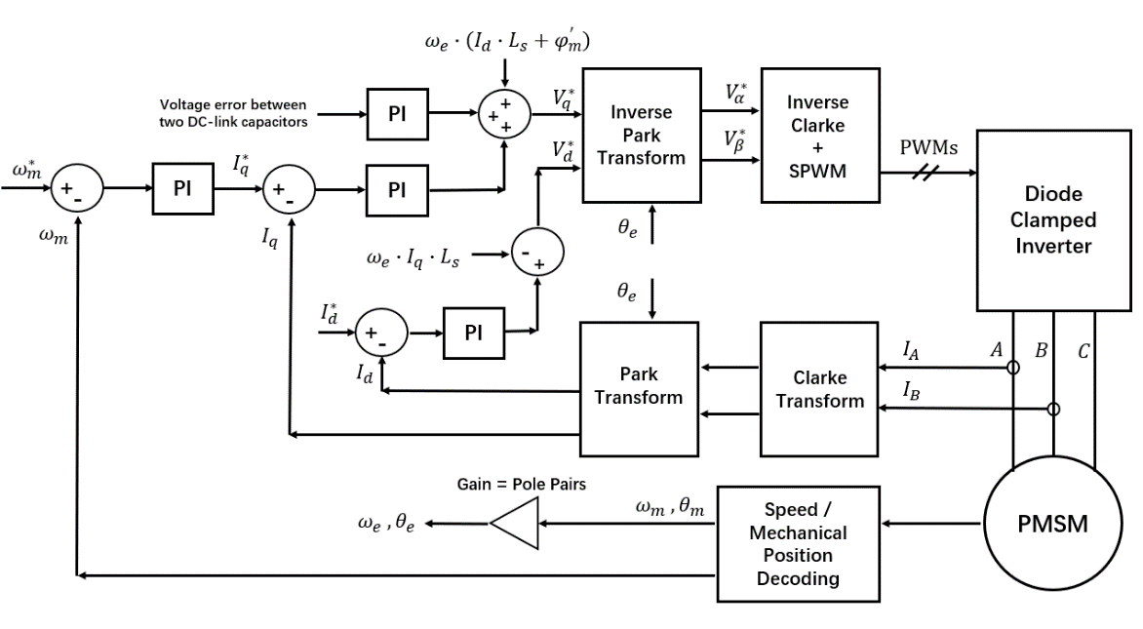

**Figure 2.6** Control Diagram

***2.5* SPWM and SVPWM**

Symmetry PWM (normal -> single and double edge)

***2.6* Design of Current and Speed Controllers**

Electromotive force constant

The motor torque and back emf constants are equal: (represented by K)

Newton’s 2nd law:

Kirchhoff’s voltage law:

Laplace transform:

Thus, plant’s transfer function of current control:

Plant’s transfer function of speed control:

Continuous -> discrete

Time delay

Crossover frequency

Phase margin

Bode / root locus / step response

***2.7* Design of DC-Link Voltage Balance Controller**

***2.8* Loss Calculations**

Thermal, switching, conducting

**Chapter 3: Hardware Design: Diode Clamped Inverter**

***3.1* PCB Layout**

* Choose of vias size, copper thickness, track width -> calculation?

***3.2* Selection of Components**

Why choose IGBT rather than MOSFET

***3.3* Gate Drive Circuit**

* Why IGBT, instead of MOSFET
* Why use DC/DC converter

***3.4* DC-Link Capacitors**

* Calculation:

* But in fact, it is hard to satisfy high voltage and larger capacitance at same time

**Chapter 4: Hardware Design: Control Board and its Peripherals**

***4.1* PCB Layout**

***4.2* ADC Sampling**

**Chapter 5: Software Design: Implementation on MCU**

***5.1* Files Structure and IDE Configurations**

***5.2* Algorithm Implementation**

**Chapter 6: System Testing, Validation, and Analysis**

***6.1* Testing and Validation**

SPWM with comparator (frequency limitation) -> single / double edge

Gate Drive -> can work

***6.2* Results Analysis**

**Chapter 7: Conclusion and Reflection**

***7.1* Consideration of System within Wider Context**

***7.2* Reflection on Management**

**References**

[1] B. Wu, “High Power Converters and AC Drives”, Wiley IEEE, 2nd Edition, 2016

[2] G. Abad, “Power Electronics and Electric Drives for Traction Applications”, Wiley, 2016

[3] A. Hughes “Electric Motors and Drives: Fundamentals, types, and applications”, 5th Edition, Elsevier, 2019

[4] S. N. Vukosavic, “Electrical Machines”, Springer, 2012